Table of Contents

Lab 1: Filtering 1

Lab 1 Filtering and Sorting 3

Data 3

Data Source Preparation Steps 3

Solution: Filtering. 3

Challenge lab 10

# Lab 1: Filtering

Objectives

Practice: Filtering

Creating Date Filters

Data Filtering

Using filters narrows the data shown in a view to focus on relevant information. Filter options vary by field type (Dimension, Measure, Date Dimension). You can use filters for any dimension or measure tin your data, and you can create custom filters on dimensions or measures.

After you create a filter, all filtered fields display on the Filters shelf in the worksheet. Use this to identify which data is included in or excluded from the view.

**Filter on a Dimension**

Use a dimension filter to view the data values for a smaller set of dimension members.

The Filter dialog box for dimensions has several filter option tabs. These filters are cumulative, meaning the settings you choose on each tab affect the others using “AND” logic. For example, if you filter the **Region** dimension to include only West (on the **General** tab), and then add conditions for a **Top 10** filter (on the Top tab), you see Top-10 data for the West only.

**Build a Filter by Dimension**

1. Drag a dimension to Filters.
2. In the Filter dialog box, set the filter criteria and click OK.

Open *.twbx and create a view according to the following specification:

Has a filter for **State**, displayed as a single value list, titled **“Select a State”** with the options to choose “ALL” disabled.

Has a filter **Favorable Determination Rate** on, formatted as a slider.

**Directions**

1. Create a filter for **State** displayed as a single value list, removing the ALL options, and titled **“Select a State”**.
2. Create a filter for **Favorable Determination Rate**, displayed as a slider.
3. Experiment with the sliders and notice the “AND” logic being used. The results shown are those that match the criteria of both filters.

## Lab 1 Filtering and Sorting

## Data

This documentation describes a publicly available dataset containing historical and current information about the processing by the Social Security Administration (SSA) of initial claims for disability benefits.  The dataset includes information from federal fiscal year 2001 onwards concerning initial claims for disability benefits that were referred to a [state agency](https://www.ssa.gov/disability/data/ssa-sa-fywl.htm#StateAgency) for a disability determination.

  Specific data elements for each state are receipts, determinations, and the number of determinations which were allowances.  Additional data is present allowing the calculation for separate eligible adult and child populations their respective SSA benefit receipt rate, disability application filing and allowance rates, and percent of claims with a favorable disability determination.  This data may be used to examine disability application filing trends by time and by state, state agency workloads, and disability claims outcomes.

A dataset containing fiscal year data can be downloaded from: <https://www.ssa.gov/disability/data/SSA-SA-FYWL.csv>.

## Data Source Preparation Steps

1. Download the file <https://www.ssa.gov/disability/data/SSA-SA-FYWL.csv> or open file from the folder **/Lab 1 – Filtering and Sorting/SSA-SA-FYWL.csv**
2. Change the Favorable Determination Rate field. Divide the existed values on 100.
3. Change the caption of column Date to the Date ID.

**Note: If you would like to make column as Dimension then add ID to the name of the column**

### Solution: Filtering.

**Preparation steps**

1. Open your instance of Tableau.
2. Drag and drop file edited file **SSA-SA-FYWL.csv** to the Open section of Tableau or open Other files and select in the folder:

**/Lab 1 – Filtering and Sorting/SSA-SA-FYWL.csv**

1. Drag and drop **Date** from **“Measures”** to the Dimension **(Optional step if you did not do 3rd step of Data source preparations).**

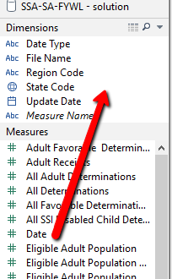

1. Drag and Drop **Region Code from the Dimension** to the Columns
2. Drag and Drop **State from the Dimension** to the Filters
3. Drag and Drop **Date ID from the Dimension** to the Rows
4. Drag and Drop **Region Code from the Dimension** to the Columns
5. Drag and Drop **All Determinations from the Dimension** to the Columns
6. On the Data pane, right-click **State**, and click Show Filter.
7. You need to get next view.

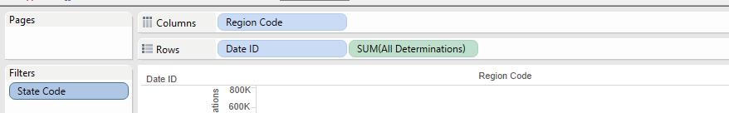

1. On the **State** filter in the view, click the drop-down arrow, and choose Single Value (List).

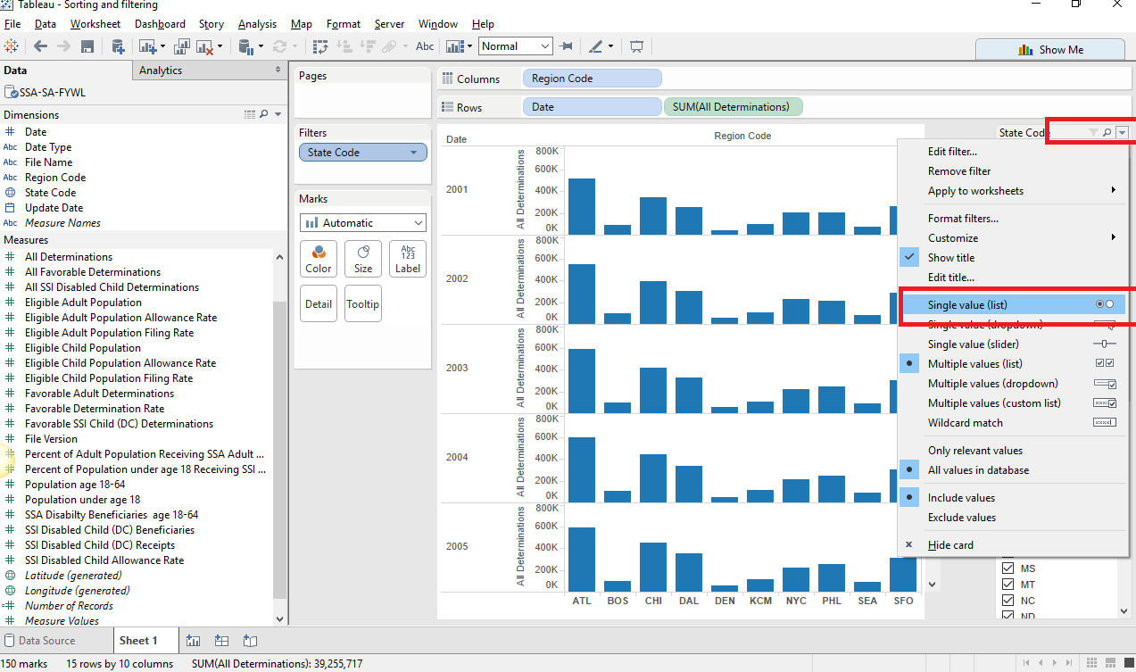

1. Now we will remove “ALL” from the filter list.

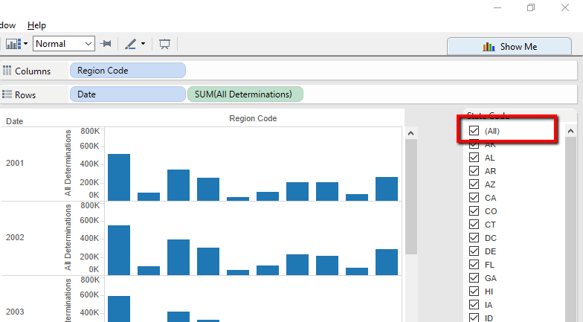

1. Click the drop-down arrow again for the **State filter** in the view, select Customize, and clear the check mark next to **Show "All" Value**.

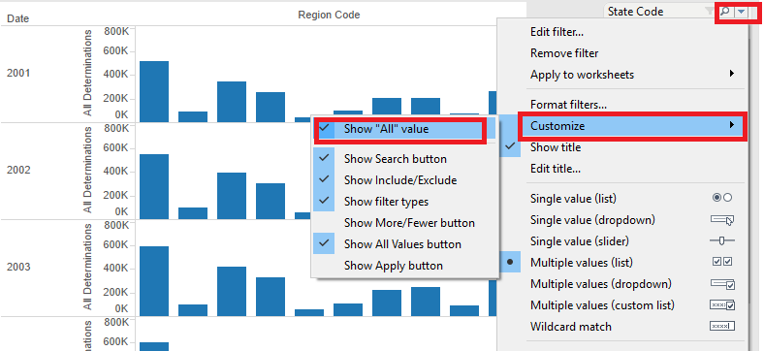

1. Click the **drop-down arrow again for the State** filter in the view and choose Edit Title.

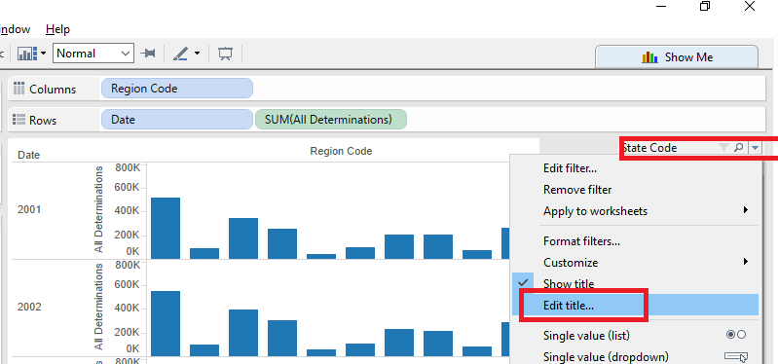

1. Name the filter **"Select a State**" and then click OK to close the dialog box.

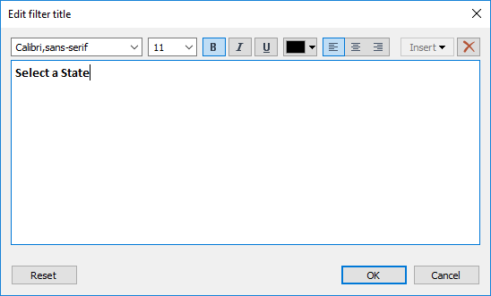

7.Right-click **Favorable Determination Rate**, select Default Properties, and click **Number Format**.

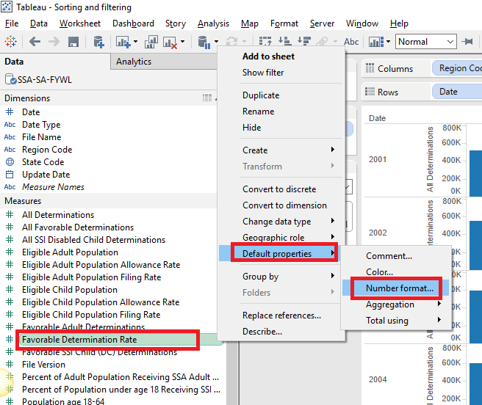

On the Default Number Format screen, select **Percentage** and click OK.

1. From Measures, drag **Favorable Determination Rate** to Filters.
2. In the Filter Field dialog box, click **Average**, click Next, and then

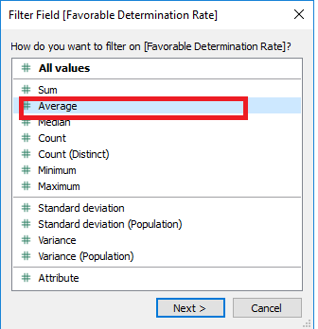

1. Click OK.

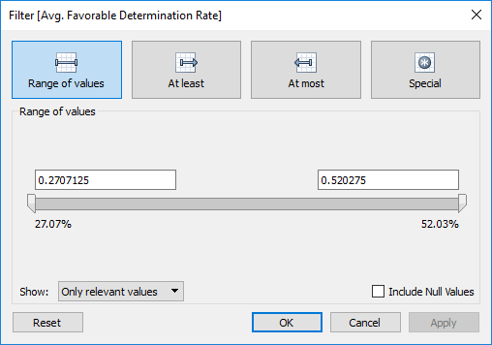

1. Right-click the **AVG**(**Favorable Determination Rate**) filter, and choose Show Filter.

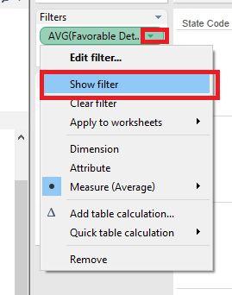

1. Click the drop-down arrow for the **AVG**(**Favorable Determination Rate**) filter in the view, and choose Edit Title.

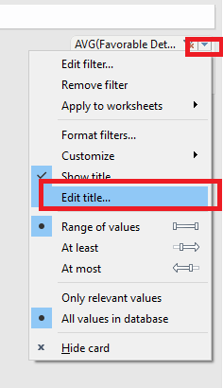

12. Name the filter "**Adjust View by Favorable Determination Rate** " and click OK.

13. Experiment with the sliders and notice the "AND" logic being used. The results shown are those that match the criteria of both filters.

NOTE: For an example of a complete solution to this practice, see **Solution Filtering.twb.**

## Challenge lab

**Set a Range of Dates Filter**

Use the range of dates filter to specify a span of time. You can also specify a starting or ending date.

In the Filter field dialog box, select Range of dates and then click Next.

Set the specific start and end dates to target. Use the slider, or select the dates from the drop-down menus and then click OK.

**Set a Starting Date or Ending Date Filter**

1. In the Filter field dialog box, select Range of dates and then click Next.
2. In the Filter dialog box, choose Starting date of Ending date.
3. Set the start date or end date, and then click Ok.

**Creating Other Date Filters**

Using the same steps as above, you can create filters for discrete dates and times.

1. In the Filter Field dialog box, select the date part you want to use as a filter and then click Next.
2. In the Filter dialog box, select the members you want to use as a filter. The list is based on your selection in the first dialog box.
3. Click OK.

**Add a Filter to the View**

After you create your date filter, add a filter to the view so users can change the data they see.

1. Right-click the field on the Filter shelf, and choose Show Filter. A filter displays in the view.
2. On the filter in the view, click the drop-down arrow

**Creating Date Filters**

Use a date filter to filter a data subset for specific date of time criteria. You can filter dates for a specific range of dates or for a discrete date/time.

**Add a Date Filter**

1. Drag a date field to the Filters shelf
2. In the Filter Field dialog box, select the type of date filter you want to use.

**Set a Relative Date Filter**

Use Relative date to update data dynamically with time. For example, set your filter to show data for 3 years before the current year. The shown in you view updates daily.

1. In the Filter Field dialog box, select Relative date and then click Next.
2. In the Filter dialog box, choose the time unit you want to use for the relative date range.
3. Next, set the specific time to target. For example, if you choose Quarters for your unit of time, the options read Previous quarter, This quarter, Next quarter. You can also specify Last N or Next N quarters, or the current Quarter to date.
4. To set the filter to a specific anchor date, select Anchor relative to, and choose a date from the menu.
5. Click OK.